1. **Which Product has minimum storage in Inventory Management?**

Query:- Select ProductName,PartNumber,ProductLabel,MinimumRequired, min(MinimumRequired) from products;

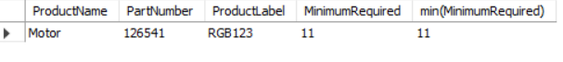

1. **Which ProductName has the Maximum Inventory Shipped?**—

Query:- Select ProductName,max(InventoryShipped) from products;

1. **Which Suppliers have provided the highest selling product?**

Query:- select supplier_name,max(NumberReceived) from purchases

join suppliers

on(purchases.supplierid=suppliers.id);

1. **Products that are ordered more than 10 times?**

Query:- Select productname, count(productid) from orders

join products

on(orders.productid=products.id)

group by productid

having count(productid)>10;

1. **Top 3 Month of the year in which numbershipped were highest?**

Query:- Select productname, count(productid), monthname(OrderDate) from orders

join products

on(orders.productid=products.id)

group by productid

order by count(productid) desc

limit 3;

1. **On Which PurchaseDate the NumberReceived of product by Supplier was highest?**

Query:- Select purchasedate, max(NumberReceived) from purchases;



1. **Supplier name from whom the inventory received is maximum?**

Query:- Select supplier_name, max(NumberReceived) from purchases

join suppliers

on(purchases.supplierid=suppliers.id);



1. **What is the average order quantity of each products?**

Query:- select productid, productname ,avg(Numbershipped) from orders

join products

on(orders.productid=products.id)

group by productid;

1. **Which Product has inventoryonhand lesser than the Minimum Required?**—

Query:- select Productname, Partnumber, Productlabel, MinimumRequired, InventoryOnHand

from products

where InventoryOnHand<MinimumRequired;

1. **Which product was Shipped to the customer more than 180 ?**

Query:- select productid,productname,productlabel, numbershipped from

products join orders

on(orders.productid=products.id)

where numbershipped>180;

1. **Name the customer,productname, productlabel, orderdate whom the product were shipped less than 50?**

Query:- select name, orderdate, productname, productlabel, orderdate, numbershipped

from products join orders

on (products.id=orders.productid)

where NumberShipped<15;

1. **Name the customer, productname, productlabel, orderdate whom the product were shipped more than 180?**

Query:- select name, orderdate, productname, productlabel, orderdate, numbershipped

from products join orders

on (products.id=orders.productid)

where NumberShipped>180;

1. **Name the customer whose inventory on hand is greater than number shipped?**

Query:- select name, orderdate, productname, productlabel, orderdate, numbershipped

from products join orders

on (products.id=orders.productid)

where NumberShipped>180;

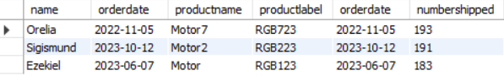

1. **Which product has the highest number of orders in the last 1 months?**

Query:- SELECT name, productname,productlabel, OrderDate,NumberShipped

FROM orders

join products

on(orders.productid=products.id)

WHERE OrderDate > (NOW() - INTERVAL 1 MONTH);

1. **Supplier name from whom the inventory received is minimum**

Query:- Select supplier_name, min(NumberReceived) from purchases

join suppliers

on(purchases.supplierid=suppliers.id);

